

Practices for Secure Software Report

Table of Contents
Document Revision History 3
Client 3
Instructions 3
Developer 4
1. Algorithm Cipher 4
2. Certificate Generation 4
3. Deploy Cipher 4
4. Secure Communications 4
5. Secondary Testing 4
6. Functional Testing 4
7. Summary 4
8. Industry Standard Best Practices 4

Document Revision History

Version | Date | Author | Comments
1.0 | June 19, 2025 | Adrian Tull

Client



Instructions

Submit this completed practices for secure software report. Replace the bracketed text with the relevant information. You must document your process for writing secure communications and refactoring code that complies with software security testing protocols.

- Respond to the steps outlined below and include your findings.
- Respond using your own words. You may also choose to include images or supporting materials. If you include them, make certain to insert them in all the relevant locations in the document.
- Refer to the Project Two Guidelines and Rubric for more detailed instructions about each section of the template.

Developer
Adrian Tull

Algorithm Cipher

  - SHA 256 or as Oracle specifies more precisely: MessageDigest SHA-256
    - SHA 256 is a cryptographic hash function that processes data in 512 bit blocks using a 256 bit hash output. The 256 makes it so only 256 bit hash values are produced as by default we would be able to use SHA 1, 224, or 256. the 256 hashes are unfeasibly difficult to brute force given a strong input, so we will require those.
    - The hash function in SHA 256 uses internal compression functions as its core mechanism. It has a bit level of 256 bit output and gives us the hash for data integrity validation and digital fingerprinting. The compression function has a bit level of 512 input blocks and gives us authentication through on way hashing of 256 bits.
    - In hash generation, we use secure encoding called UTF 8 character sets to prevent things like character encoding attacks and make sure that we have a hash generation that can be consistently reporduced. Hash functions can only create digests and cannot reverse data and can process data super fast. The main benefit is that you can verify data integrity without needing to store the original data which is why this is used for data that needs verification.
    - The Secure Hash Algorithm became global standard in 1993. There are alternatives like BLAKE3 for high performance circumstances, we still use SHA as the standard because it is resistant to collision attacks.

Certificate Generation
Insert a screenshot below of the CER file.

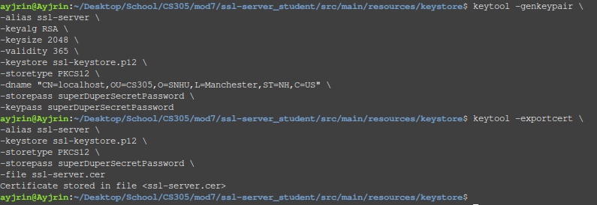
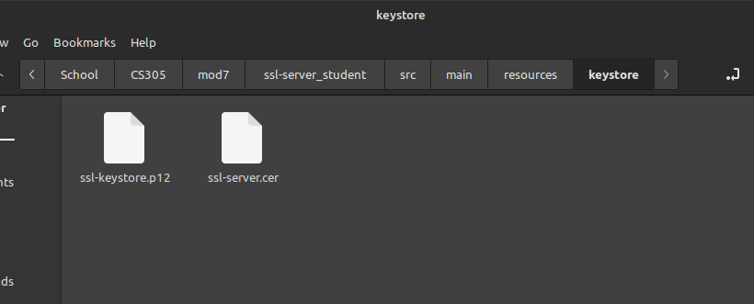
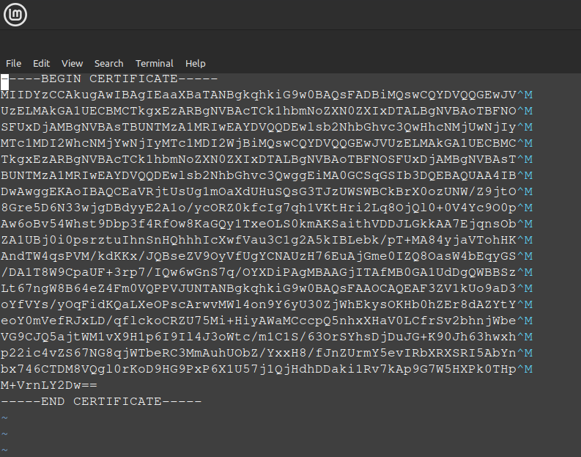

Deploy Cipher
Insert a screenshot below of the checksum verification.

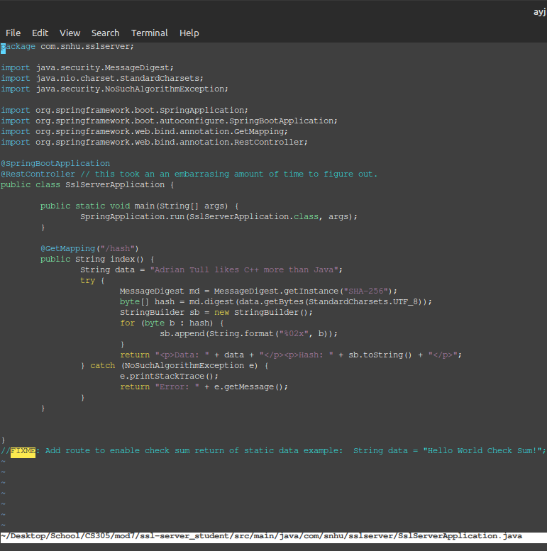

Secure Communications
Insert a screenshot below of the web browser that shows a secure webpage.

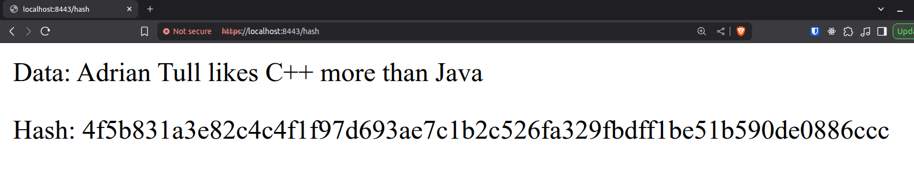
Afer some digging, I discovered the Brave browser crosses out the HTTPS because the cert is self signed. It apparently needs to be CS signed. Since the site works with https in the url, we know https is working even though we get the warning. If this is incorrect and I missed a step, I would appreciate some feedback on how to properly do it.

Secondary Testing
Insert screenshots below of the refactored code executed without errors and the dependency-check report.

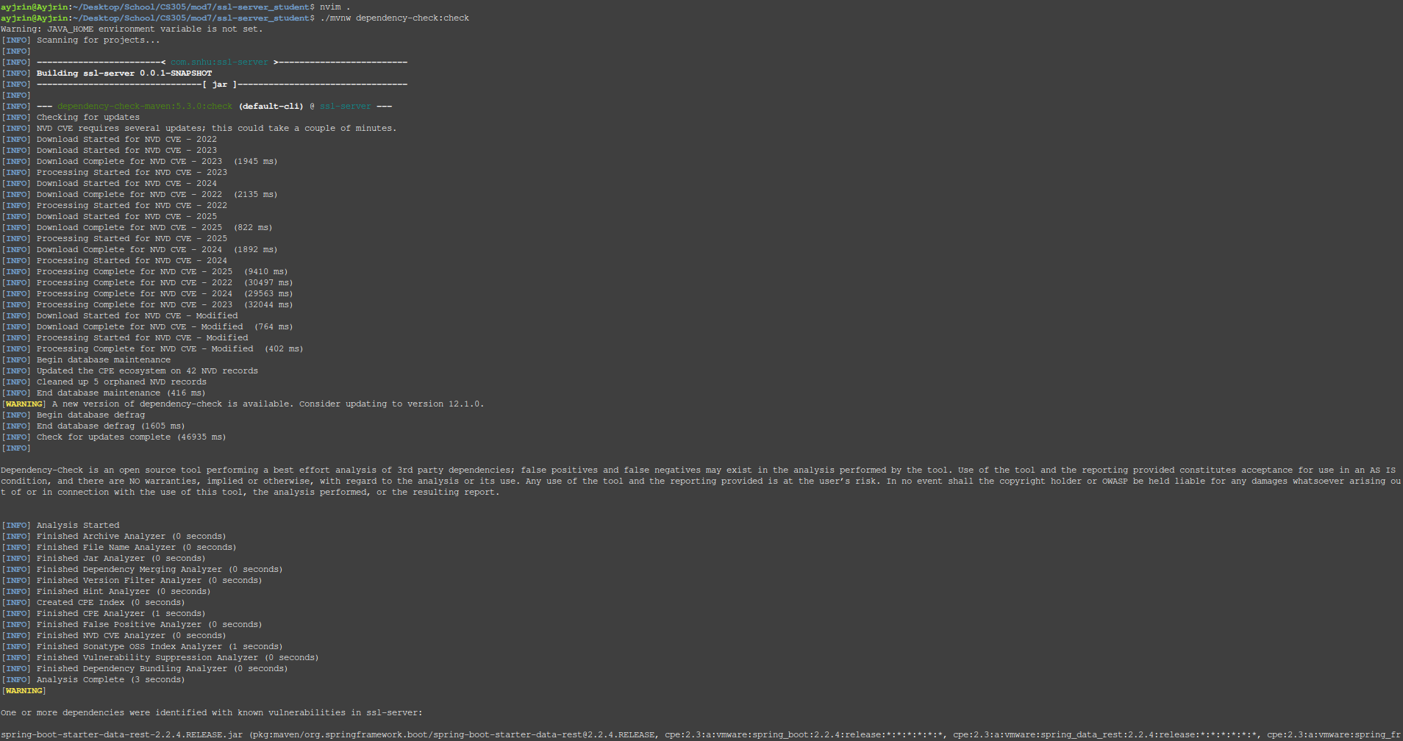
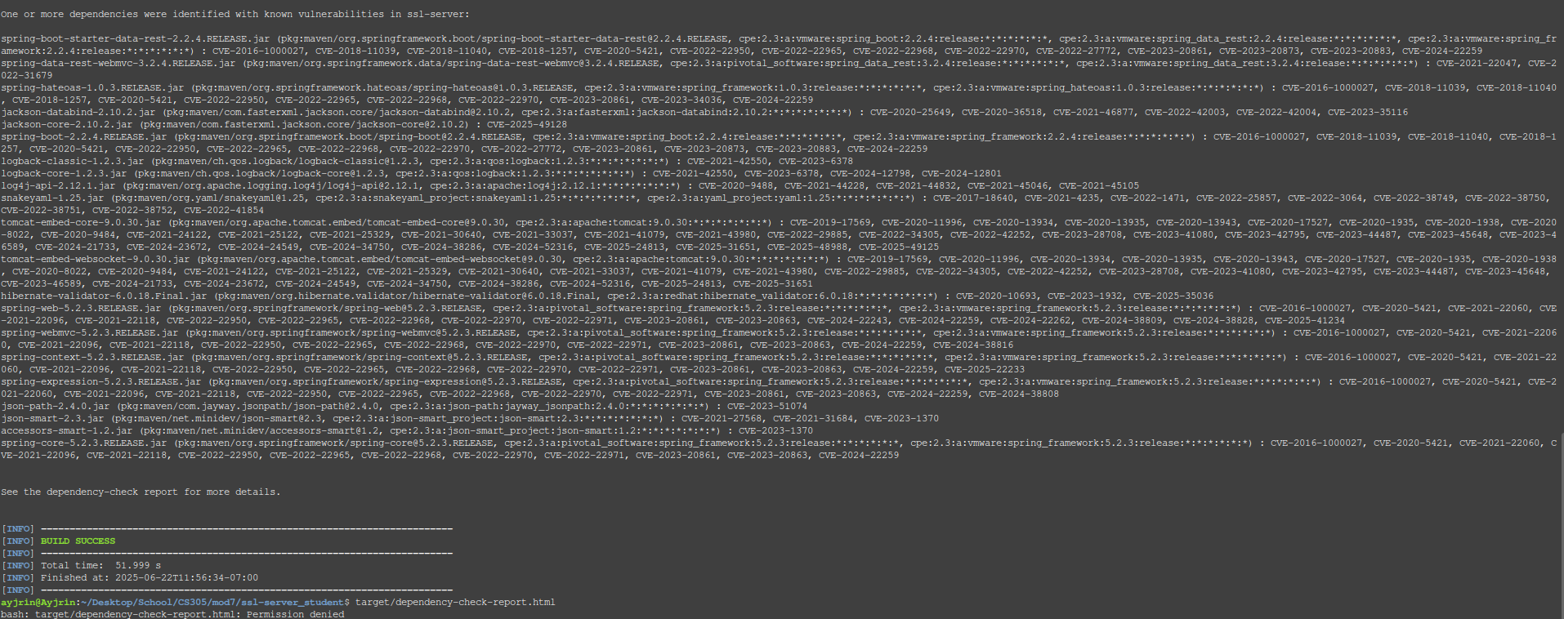

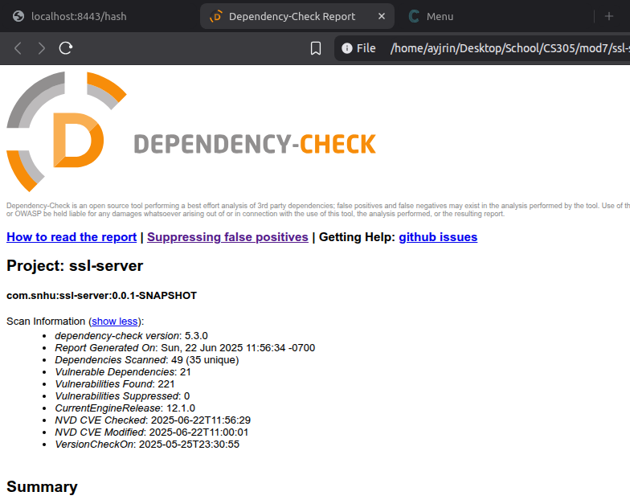

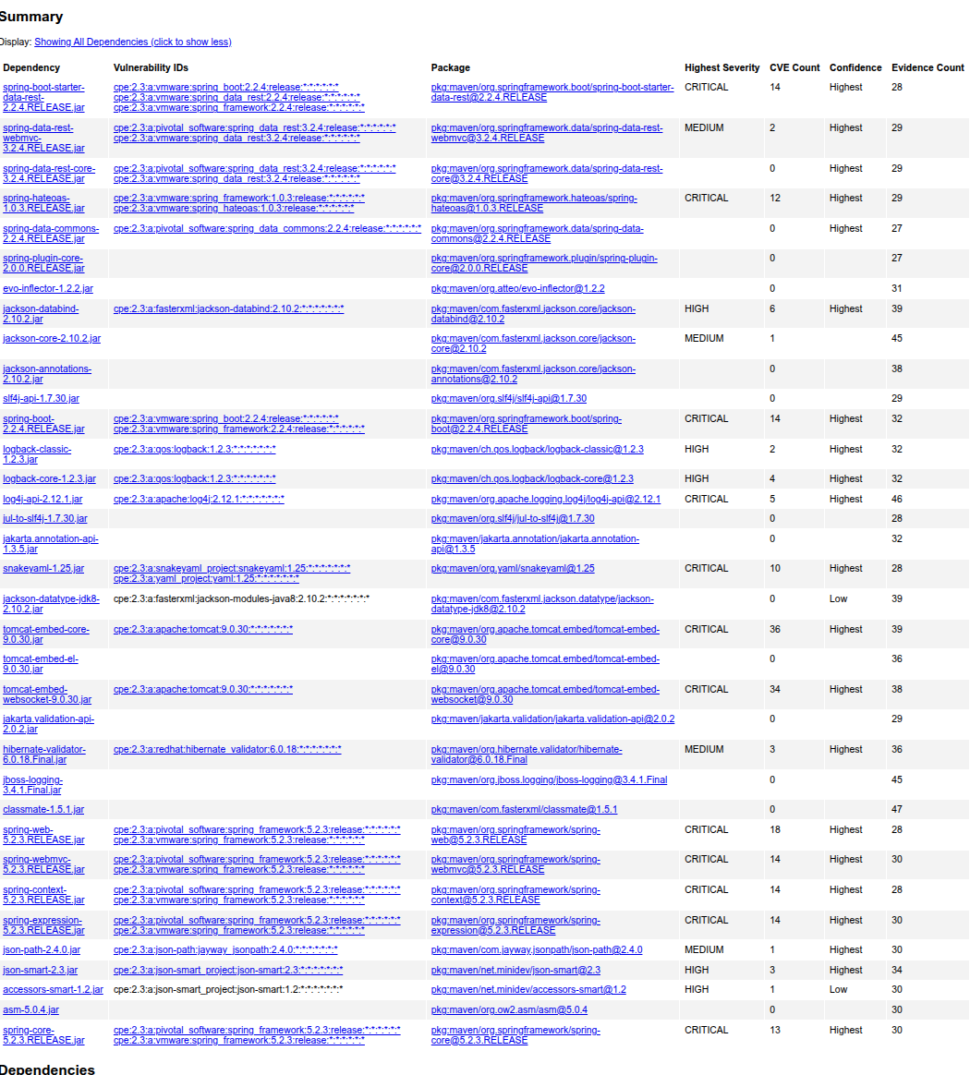

Functional Testing
Insert a screenshot below of the refactored code executed without errors.

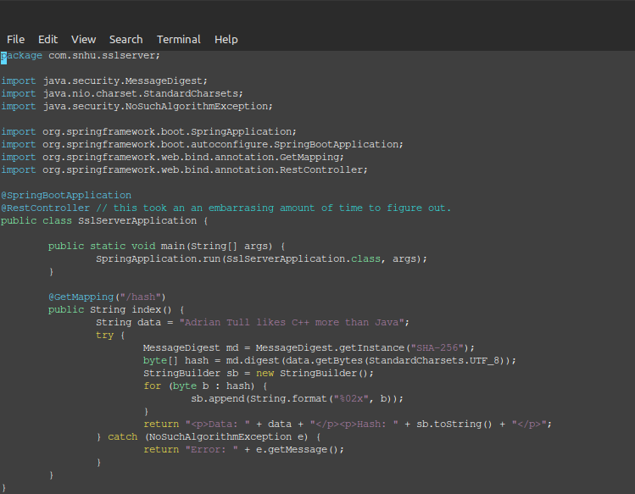

The only thing that I refactored was in my catch statement, I printed the stack trace for debugging, but since I wouldnt push that to prod in other projects, I decided to take it out here as well so any nefarious activity has less info to go off of.

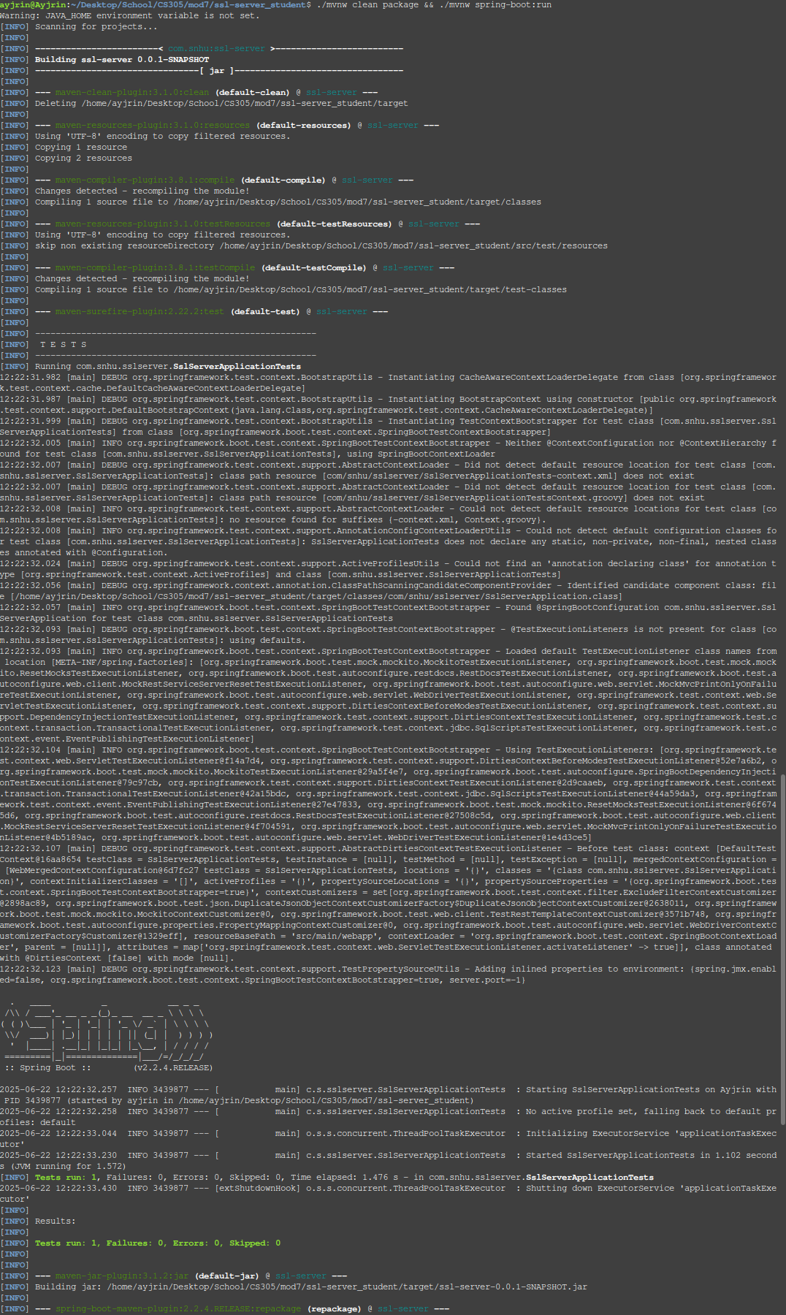

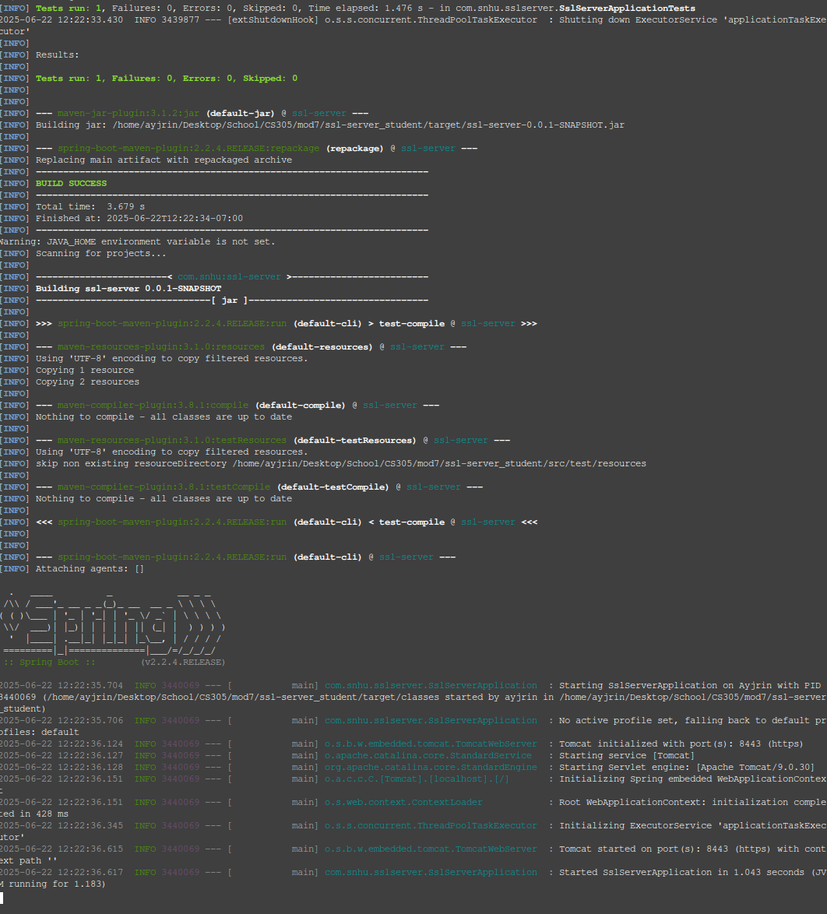

Build still successfully completes with no errors.

Summary

Refer to the vulnerability assessment process flow diagram in the Supporting Materials section. Highlight the areas of security that you addressed by refactoring the code.

  - Architecture Review
    - the web app had incomplete SSL configuration and no cryptographic implementation with placeholder SSL values
  - APIs
    - There was no secure API interactions that were defined. I created “secure” (but no auth implemented since that was out of scope) REST endpoints with proper annotations
  - Cryptography
    - There was no crypto, so I implemented a SHA 256 algorithm
  - Client / Server
    - before there was only http communication so I implemented https communications with a self signed cert.
  - Code Error
    - there was no exception handling which would lead to crashes with no way to know what went wrong.
  - Code Quality
    - There were dangling FIXMEs, no actual logic in the code, placeholders for the config, and all of that was replaced accordingly with correct structure and docs. I wouldn’t call it production ready since it would be a pretty bad idea to expose an API with no rate limiting, tracking, more robust error handling, or auth, etc. but it meets spec.
  - Encapsulation
    - there were no data proection mechanisms, but now there is a secure data structure with a conrolled access pattern.

Discuss your process for adding layers of security to the software application.

- The process for adding layers of security means implementing multiple security controls at different levels to create better protection. I started with the SSL cert and configuring https, then higher up we have TLS encryption, followed by coding practices with SHA 256 hashing and exception handling.

Industry Standard Best Practices

Explain how you used industry standard best practices to maintain the software application’s existing security.

- The goal was to follow the OWASP guidelines for secure coding and implementing things like layers of security throughout the application. This layered approach helped make sure that each seccurity feature complimented each other rather than replacing one another. The goal with the approach is to maintain current security while increasing protection while keeping backwards compatibility. If there was more code in the program, I would have made sure to implement these things, but due to the lack of content originally in the program, I had to implement the basics of the security from the ground up rather than adding to what was already there.

Explain the value of applying industry standard best practices for secure coding to the company’s overall well-being.

- Applying industry standard coding practices will prevent things like data breaches that will cost the company in brand, loss of customers, and loss of money. These practices are likely a government compliance issue so may be a cost of business that is required by law.

